**NAM**E: LUBNA

**COURSE**: BUSINESS ANALYST

**EMAIL**: [syedamina454@gmail.com](mailto:syedamina454@gmail.com)

PHONE: 6006834500

**TrianglesData:**

The TRIANGLES table is described as follows**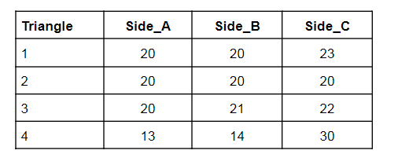Questions:1** Write a query to create theTRIANGLES table.(Note:In answer,submit all the table creation queries.)

**ANSWER1)**

THIS IS HOW I MADE TABLE AND INSERTED THE VALUES:

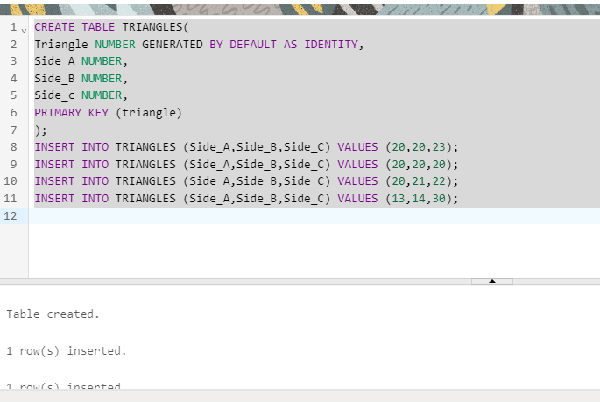

HERE’S THE SOLUTION OF IT…

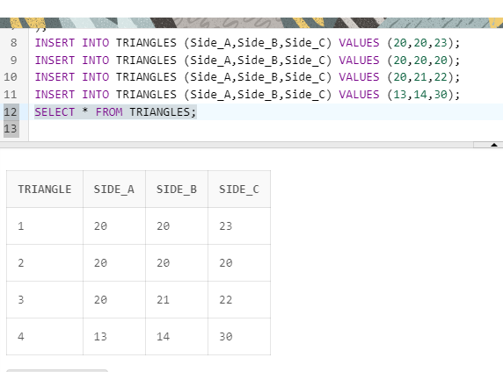

**Q2.) Writequeriestogetoutputasperrequired:**

1. Writa query to obtain the sum of side_A of all riangles.

**ANSWER2)**

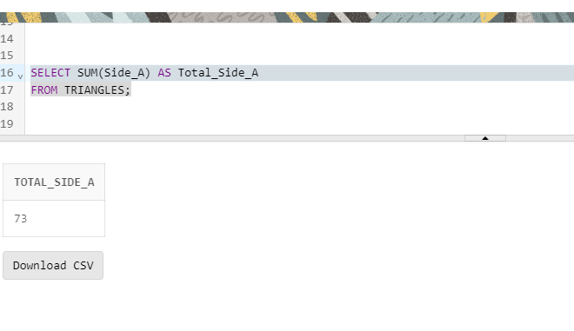

1. Write a query to obtain an equilateral triangle from the table.

**ANSWER ii)**

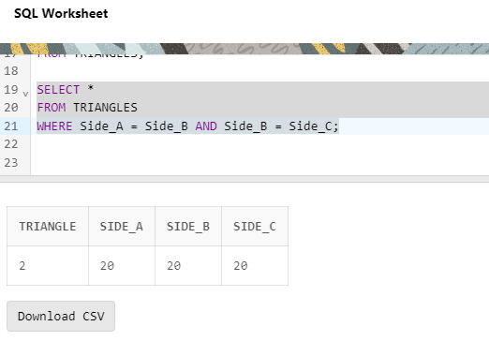

1. Write a query to obtain an isosceles triangle from the table.

**ANSWER**

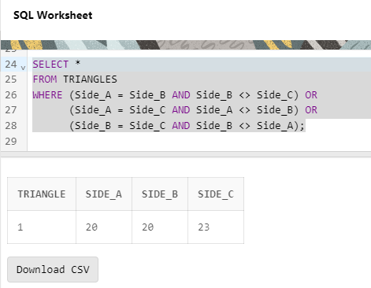

1. Find the no.of triangles in the table.

**ANSWER**

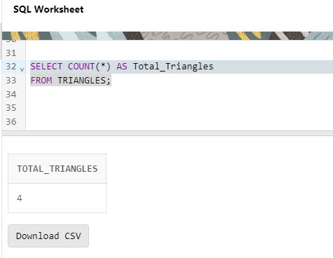

v)Find the length of side_B of Triangle 3.

**ANSWER**

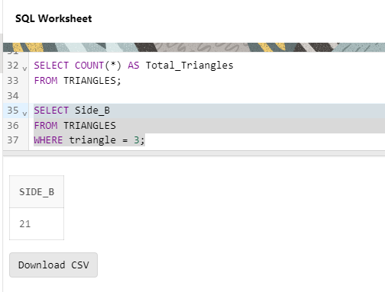

**PART 2-EmployeesData**

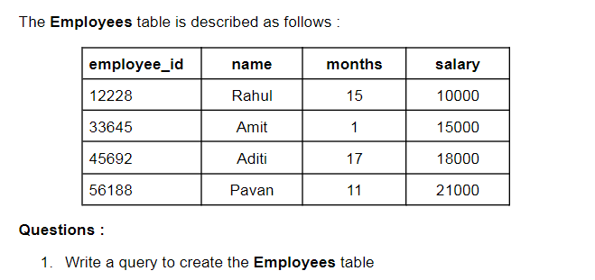

**ANSWER1)**

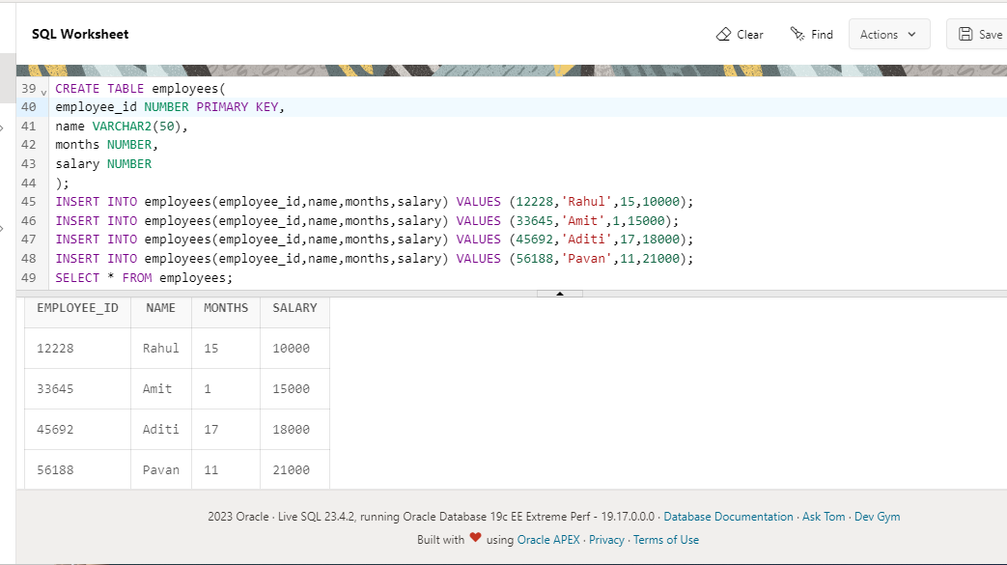

2.Write queries to get output as per required:

i)Count the total no.of employees.

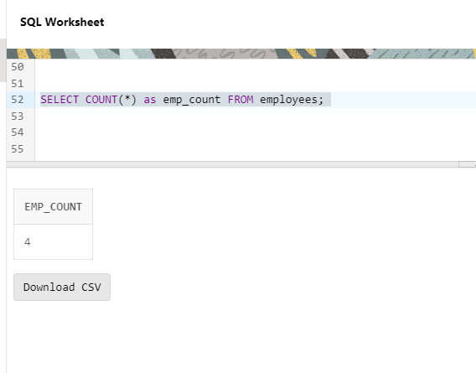

ii) Find the salary of Rahul.

**ANSWER**

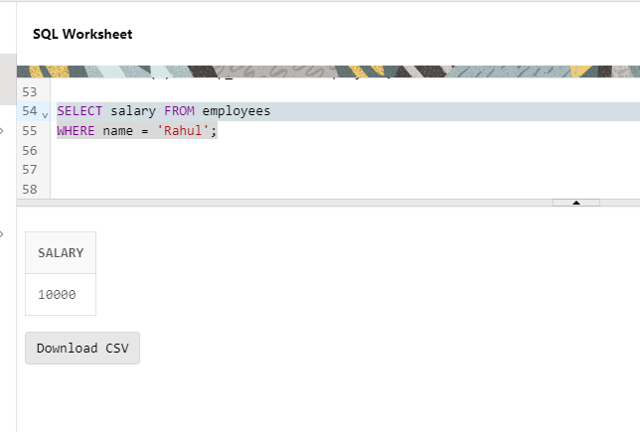

iii) Set Amit’s months to12.

**ANSWER**

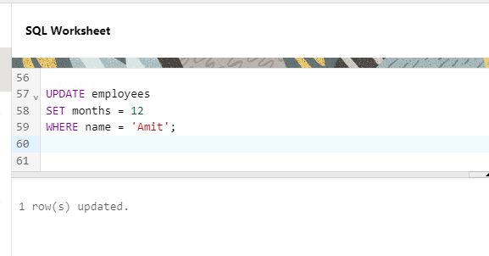

1. Find the sum of salaries of all employees.

**ANSWER**

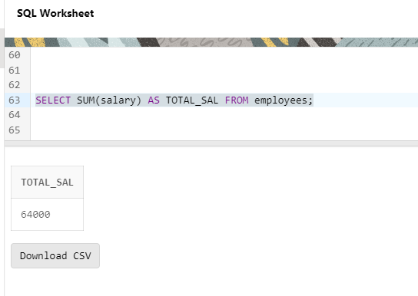

v)Find no.of employees whose name starts with ‘A’.

**ANSWER**

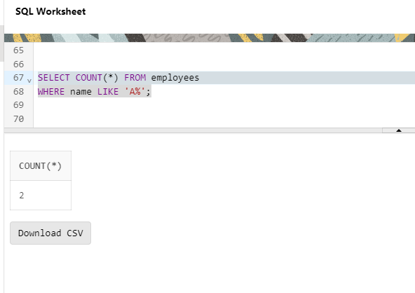

**END – OF-ASSIGNMENT**